Piece value calculation

A method to calculate FIDE and Musketeer chess piece values

November 14, 2018

Doc. v0.4.0

# Piece Value Calculation

Contents

A. Introduction 1

B. Mobility 1

Distance mobility 1

Direction mobility 2

C. Calculation 2

Here are the 3 major criteria 2

Example calculation 2

1. Queen 2

D. More example calculations 4

1. Knight 4

2. Bishop 4

E. Musketeer chess 5

1. Leopard 5

F. Opening and Ending Piece Values 6

# A. Introduction

There are some methods of calculating/estimating piece values, one is thru actual experience from playing games, machine learning by optimizing piece values from results of the games or from evaluation of millions of positions and others.

In this article I will be describing a simple approach using mobility as the main criteria to calculate its value relative to other pieces. It consists of calculating the distance mobility from the central square, the number of directions and the penalty for color-bound piece type.

# B. Mobility

Piece mobility is an important factor in determining the value of a piece. It affects how the game would continue, for example a piece with lesser mobility is limited by the positions it is able to create. The advantage of a piece having high mobility is that it has potential to discover many positions which increases its chances to have favourable positions.

### Distance mobility

Consider figure 1, the queen is a very mobile piece in a game. It has 8 different directions making it very difficult to defend when it is attacking. It also has 3 counts of mobility that can reach a distance of 4 squares from its location at square E4. The 3 squares are A4, A8 and E8 or those marked with 4 on the board. This makes it a dangerous piece even at long distance.

Another strong property of this piece is that it has 8 counts of squares that it controls at a distance of 1 from E4 square, these are E5, F5, F4, F3, E3, D3, D4 and D5 or all those squares that are marked with 1, which would mean that opponent’s pieces cannot easily attack this piece at close range.

### Direction mobility

Apart from the distance mobility another criteria that would contribute to the calculation of a piece value is the number of directions. In Figure 1, queen has 8 directions. The higher the direction the more dangerous the piece is.

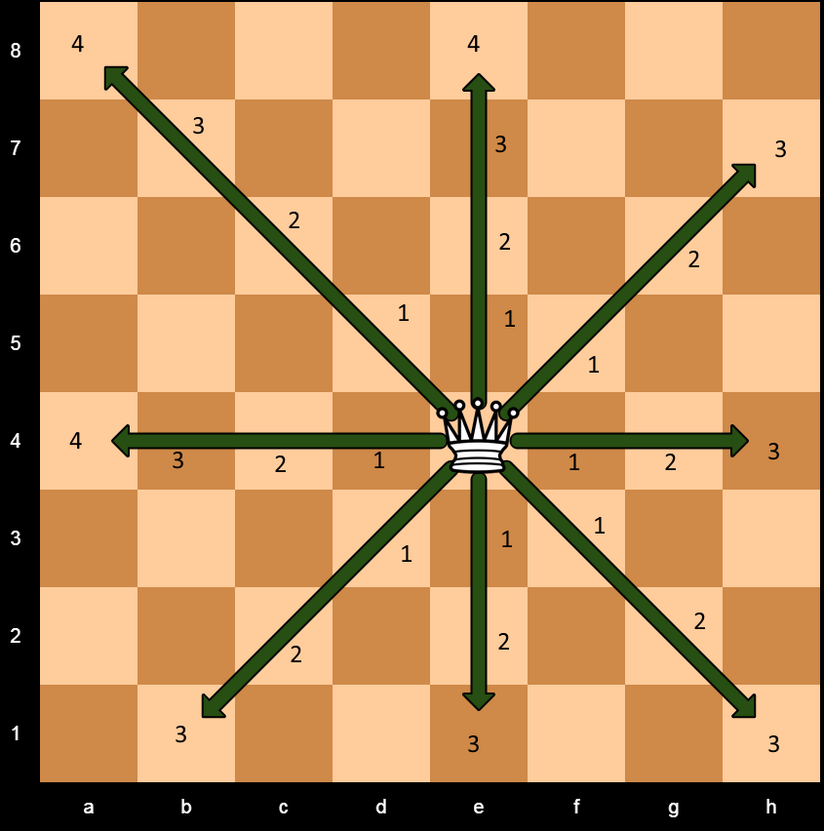

Figure 1: Queen at E4 square and its distance mobility counts

# C. Calculation

Piece value calculation will be based on the mobility described in mobility section and some other criteria. For every piece we store its mobility by a number of different ways a piece can move to at different distances. We also store the number of directions. Piece that can only move on one color (color-bound) like bishop will be given a penalty.

### Here are the 3 major criteria

1. Mobility at specific distances
2. Number of directions
3. Color bound penalties

In criteria (1) and (2) some factors will be applied to get its initial value.

## Example calculation

### 1. Queen

Location square: E4

Variant: chess

#### a. Mobility

Md1 = 8 (Mobility at distance 1)

Md2 = 8 (Mobility at distance 2)

Md3 = 8 (Mobility at distance 3)

Md4 = 3 (Mobility at distance 4)

Each criteria will be multiplied by a factor to get its value contribution. See Table 1 for mobility factors.

Value = criteria x factor [Formula 1]

**Table 1: Mobility factors**

|  |  |  |  |
| --- | --- | --- | --- |
| Md1f | Md2f | Md3f | Md4f |
| 50 | 30 | 24 | 12 |

We will use formula 1 to get its mobility values

Md1v = Md1 x Md1f = 8 x 50 = 400

Md2v = Md2 x Md2f = 8 x 30 = 240

Md3v = Md3 x Md3f = 8 x 24 = 192

Md4v = Md4 x Md4f = 3 x 12 = 36

Mdv1, Md2v and others are based on centipawn value, or 1 pawn = 100

Total mobility value = Md1v+Md2v+Md3v+Md4v = 400+240+192+36 = 868

#### b. Number of directions

The more directions a piece has the more it becomes valuable as it can move at different directions, which is difficult to trap/capture.

**Table 2: Number of direction factor**

|  |  |
| --- | --- |
| **direction factor** | **8** |

Number of directions = 8

We will use formula 1

Value = Number of directions x factor

Dirv = 8 x 8 = 64

Total direction value = 64

#### c. Color bound penalty

Penalty is zero because a queen can move to a different color from its original square at E4

Final value will be the sum of the distance mobility values plus the direction value less penalty.Final value = Mobility value + direction value – color-bound penalty [Formula 2**]**

**Queen final value = 868 + 64 – 0 = 932**

# D. More example calculations

### 1. Knight

Location square: E4

Variant: chess

#### a. Mobility

Md1 = 0

Md2 = 8

Md3 = 0

Md4 = 0

See table 1 for mobility factors

Md2v = 8x30 = 240

Total Mobility value = 240

#### b. Direction

Number of directions = 8

See Table 2 for direction factor

Dirv = 8 x 8 = 64

Total direction value = 64

#### c. Color-bound penalty

Penalty = 0

**Knight final value = 240 + 64 – 0 = 304**

### 2. Bishop

Location square: E4

Variant: chess

#### a. Mobility

Md1 = 4

Md2 = 4

Md3 = 4

Md4 = 1

See table 1 for mobility factors

Md1v = 4x50 = 200

Md2v = 4x30 = 120

Md3v = 4x24 = 96

Md4v = 1x12 = 12

Total Mobility value = 428

#### b. Direction

Number of directions = 4

See Table 2 for direction factor

Dirv = 4 x 8 = 32

Total direction value = 32

#### c. Color-bound penalty

Penalty = (Mobility value + Direction value)/3

Penalty = (428+32)/3

Penalty = 460/3 = 153

**Bishop final value = 428 + 32 – 153 = 307**

**Table 3: FIDE chess pieces with piece values in centipawn**

|  |  |  |  |  |  |  |  |
| --- | --- | --- | --- | --- | --- | --- | --- |
| **Type** | **Md1v** | **Md2v** | **Md3v** | **Md4v** | **Dirv** | **Penalty** | **Final** |
| **Knight** | **0** | **240** | **0** | **0** | **64** | **0** | **304** |
| **Bishop** | **200** | **120** | **96** | **12** | **32** | **153** | **307** |
| **Rook** | **200** | **120** | **96** | **24** | **32** | **0** | **472** |
| **Queen** | **400** | **240** | **192** | **36** | **64** | **0** | **932** |

# E. Musketeer chess

### 1. Leopard

Location square: E4

Variant: musketeer chess

Leopard is a one of the pieces in musketeer chess variant. It can move like a knight. It also can move like a bishop but is limited to a distance of 2 squares in any direction from its origin. Visit <http://musketeerchess.net/site/game-rules/> for the rest of the musketeer chess piece movements.

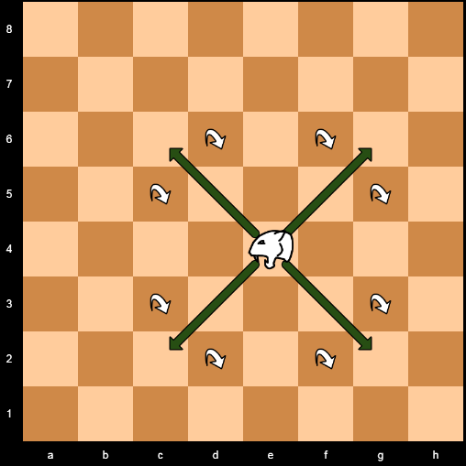

Figure 2: Leopard piece in Musketeer chess variant

#### a. Mobility

Md1 = 4

Md2 = 12

Md3 = 0

Md4 = 0

See table 1 for mobility factors

Md1v = 4x50 = 200

Md2v = 12x30 = 360

Total Mobility value = 560

#### b. Direction

Number of directions = 12

See Table 2 for direction factor

Dirv = 12 x 8 = 96

Total direction value =96

#### c. Color-bound penalty

Penalty = 0

**Leopard final value = 560 + 96 – 0 = 65**

**Table 4: Musketeer chess variant piece values in centipawn**

|  |  |  |  |  |  |  |  |
| --- | --- | --- | --- | --- | --- | --- | --- |
| **Type** | **Md1v** | **Md2v** | **Md3v** | **Md4v** | **Dirv** | **Penalty** | **Final** |
| **Leopard** | **200** | **360** | **0** | **0** | **96** | **0** | **656** |
| **Cannon** | **400** | **240** | **0** | **0** | **96** | **0** | **736** |
| **Unicorn** | **0** | **240** | **192** | **0** | **128** | **0** | **560** |
| **Dragon** | **400** | **480** | **192** | **36** | **128** | **0** | **1236** |
| **Chancellor** | **200** | **360** | **96** | **24** | **96** | **0** | **776** |
| **Archbishop** | **200** | **360** | **96** | **12** | **96** | **0** | **764** |
| **Elephant** | **400** | **240** | **0** | **0** | **64** | **0** | **704** |
| **Hawk** | **0** | **240** | **192** | **0** | **64** | **0** | **496** |
| **Fortress** | **200** | **360** | **96** | **0** | **96** | **0** | **752** |
| **Spider** | **200** | **480** | **0** | **0** | **128** | **0** | **808** |

# F. Opening and Ending Piece Values

Piece values can be further sub-divided into opening/middle and ending phases. Strong pieces like queen and dragon can be reduced in the opening phase as their power cannot be fully utilized because of the high number of opponent’s minor pieces and the board is still crowded, there is less room to maneuver.

In contrast a knight can have higher piece value in the opening than in the ending. It has a dangerous forking ability which is effective in the middle phase.